Configuration Management Plan

For OMMCOM News Portal

Version 1.0

Luminous Infoways Pvt. Ltd.  
  
Address: N6-373, IRC Village,  
Bhubaneswar - 751 015, Odisha, India  
Phone: +91 674 2360573, +91 674 6451236  
Fax: 91 674 2360724  
Web:www.luminousinfoways.com

**Revision History**

|  |  |  |  |  |  |
| --- | --- | --- | --- | --- | --- |
| Version (x.y) | Date of Revision | Description of Change | Reason for Change | Affected Sections | Approved By |
| Version 1.0 | 07/04/16 | Initial Release | Configuration Management Plan | ALL | Debasish Mishra (Project Manager) |
|  |  |  |  |  |  |
|  |  |  |  |  |  |

**Approval History**

|  |  |  |  |
| --- | --- | --- | --- |
| Version (x.y) | Prepared By | Reviewed By/Date | Approved By/Date |
| Version 1.0 | Samadhan Mishra | Debasish Mishra / 04/04/16 | Samadhan Mishra/ 04/04/16 |
|  |  |  |  |

Table of Contents

1 Introduction 4

1.1 Purpose 4

1.2 Scope 4

1.3 Project Overview 4

1.4 Definitions and Acronyms 5

1.5 References 5

1.6 Assumptions and Dependencies 5

2 Configuration Management 5

2.1 Configuration Team Structure, Roles and Responsibilities 5

3 Configuration Management Approach 6

3.1 SCM Tools & Techniques 6

4 Configuration Management Scope 6

4.1 Configuration Identification 6

4.1.1 Non-Configurable Items 7

4.2 Directory Structure 7

5 Configuration Management Activities 7

5.1 Version Control 7

5.2 Change Management 8

5.3 Baseline Tracker 8

5.4 Build Management 8

5.4.1 Build Environment 8

5.5 Release Management 8

6 Configuration Control 8

6.1 Configuration Status Accounting 8

6.2 Configuration Audits and Reviews 9

6.3 Third Party Items 9

6.4 Training 9

6.5 Backup 9

# Introduction

The purpose of a CM Plan is to establish a sound CM approach that maintains the integrity of Project’s systems and provides traceability for changes incorporated into the environment. The CM process integrates the technical and administrative actions of identifying the functional, performance and physical characteristics of a configuration item (CI) and controls the changes to those characteristics.

CM implements a process by which the project manager and stakeholders identify, communicate, implement, document and manage changes in the systems environment.

## Purpose

The purpose of this document is to specify the configuration management approach, model, tools and processes required to support for OMMCOM News Portal.

All the stakeholders of this project will be benefitted from this document. The list of stakeholders is as follows:

|  |  |
| --- | --- |
| Stakeholders’ Name | Stakeholders’ Description |
| Debasish Mishra | Project Manager |
| Satyakam Misra | System Analyst |
| Samadhan Mishra | System Architect |
| Prativa Samal | HR |
| Subrata Rout | Sr. Developer |
| Debashrita Mohanty | Developer |
| Suhasini Reddy | Mobile App Developer |
| Debi Prasad Behera | Web Designer |
| Ashok Sahoo | DBA |
| Sarada Prasan Behera |  |
| Mousumi Panda | Quality Analyst |

## Scope

* CM Applicability
  + QMS
  + Project Documents
  + Source Code
* Limitations/Constraints
  + Change in customer requirements.
  + Availability/unavailability of resources.
  + Change in design plan.
* Assumptions for CM Plan
  + No significant change in requirement from client.
  + Resources are available during the course of project.

## Project Overview

## This document showcases OMMCOM's Media Pvt. Ltd. Web & mobile app which makes it easier for the viewers to read news on the fly and participate in live video conferences as well. Viewers shall be able to post their comments for any news/article and share any news/article in social media with ease.

## Definitions and Acronyms

## References

Configuration Management Policy v1.1.doc

## Assumptions and Dependencies

* + No significant change in requirement from client.
  + Resources are available during the course of project.
  + Change in project management plan.

# Configuration Management

## Configuration Team Structure, Roles and Responsibilities

| Role | Person | Responsibilities |
| --- | --- | --- |
| HOIT |  |  |
| Project Manager | Debashish Mishra | Project Management |
| Developer | Subrat Rout, Debasrita Mohanty, Suhasini Reddy | Software Development |
| Tester | Mousumi Panda | Software Testing |
| Configuration Manager/ Controller | Samadhan Mishra | Configuration Manager |

# 

# Configuration Management Approach

## SCM Tools & Techniques

* Github used for version control //Proof to be attached

# Configuration Management Scope

## Configuration Identification

| Configuration  Item | Naming Convention | Storage Location | Criteria for Baseline | Retention Period | Type of Disposition |
| --- | --- | --- | --- | --- | --- |
| Source Code | OMMCOM_Source |  | Completion of Code Review | 6 Months | Back on NAS |
| Project Management Plan | OMMCOM_Project_Management |  | Review & Completion of Project management Plan | 6 Months | Back on NAS |
| Configuration Management Plan | OMMCOM_Configuration Management Plan |  | Review & Completion of Configuration management Plan | 6 Months | Back on NAS |
| HLD/ DD | OMMCOM_High Level Design  OMMCOM_Detailed Design |  | Completion of Design Review | 6 Months | Back on NAS |

### Non-Configurable Items

| Item Name | Naming Convention | Storage Location | Retention Period | Type of Disposition |
| --- | --- | --- | --- | --- |
| Timesheets |  |  |  |  |
|  |  |  |  |  |
|  |  |  |  |  |
|  |  |  |  |  |
|  |  |  |  |  |

## Directory Structure

|  |  |  |  |  |
| --- | --- | --- | --- | --- |
| Role | Access | | | |
| Create | Read | Write | Delete |
| Configuration Manager | Yes | Yes | Yes | Yes |
| Project Manager | Yes | Yes | Yes | No |
| Developer | Yes | Yes | Yes | No |
| System Analyst | Yes | Yes | Yes | No |
| QA | Yes | Yes | Yes | No |
| HR | Yes | Yes | Yes | No |
| DGM,Operations | No | Yes | No | No |

# Configuration Management Activities

The tool that has been used to carry out various Configuration Management Functionality based on the development, technical and operational architecture is Github for OMMCOM News Portal Project.

## Version Control

Version control is done automatically by GitHub.com

## Change Management

* Any sort of change from the client is to be registered in the change request form and maintained in change request tracker.

## Baseline Tracker

<This section provides the list of baselines that are tracked at the end of each milestone or phase. >

## Build Management

Build Management will be automated via Github.

There will be two builds of the software.

### Build Environment

Build/Product integration environment used: Github

## Release Management

|  |  |
| --- | --- |
| SDLC Stage | Release Process Phases |
| Development | Release Policy/Planning, SW/HW Design |
| Testing | Build & Configure Release, QA, Release Accepted, Rollout Plan, Communicate & Train |
| Production | Implement Release, Verify Implementation |

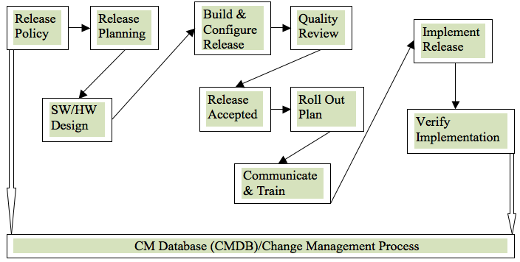

# Configuration Control

## Configuration Status Accounting

Refer Configuration Accounting Report v1.0

## Configuration Audits and Reviews

Refer Internal Quality Audit Plan v 1.0

## Third Party Items

List of Third party tools;

GitHub.com

Sublime 3

XAMPP 1.8

## Training

QMS Training

## Backup

Project data backup will be taken by the Infrastructure (Network & System Admin) team as per the Infrastructure back up policy.

CC will verify every week for restoration of the data with the Infrastructure team on the back ups taken.